**LAB Manual 18**

**Rider**

<https://play.google.com/store/apps/details?id=com.ketchapp.rider>

* Download/Install Unity 5.6.0 or above versions
* Glowing LineSegment

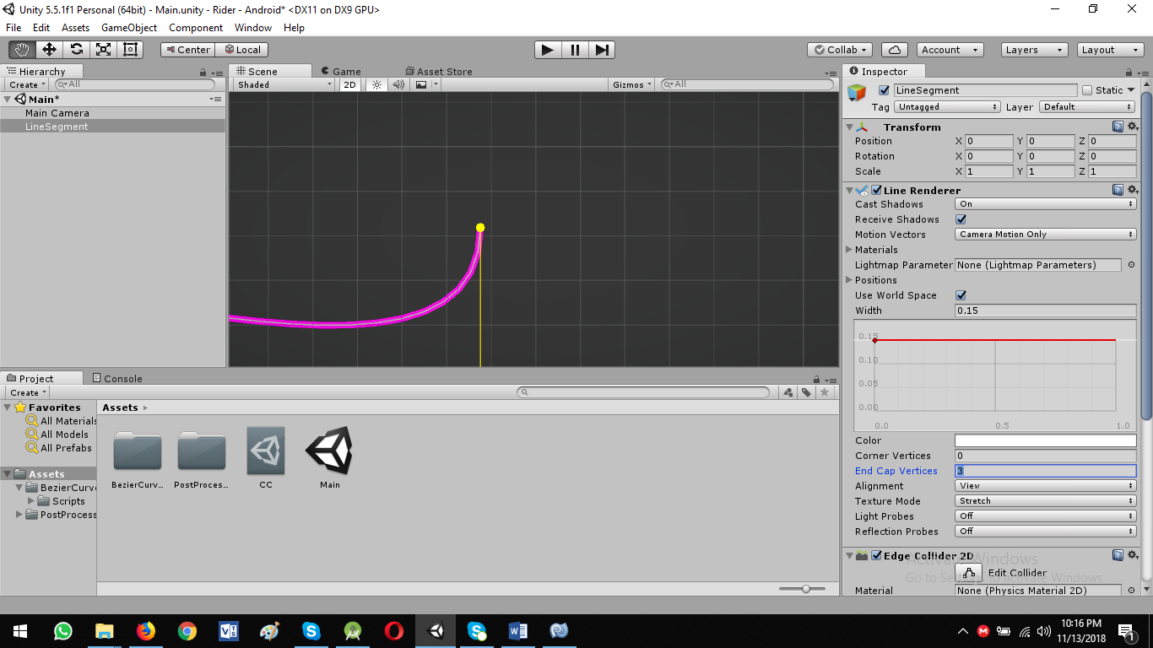

Now add custom material to our line

* Project Panel -> Create -> Material -> Rename it: LinePurple

We want to add glowing in our line: Let’s add new custom extension MK Glow Free

<https://assetstore.unity.com/packages/vfx/shaders/fullscreen-camera-effects/mk-glow-free-28044?aid=1101lPGj&utm_source=aff>

Download and Import this from Asset Store: **MK Glow Free**

* Used this extension for materials to glow
* You can see different glowing objects in MKGlowFree->Demo->Materials-> Views & Textures

Now let’s add the MKGlowFree script to Main Camera

* Select Main Camera and drag the MKGlowFree script and add below Post Processing Behavior script.

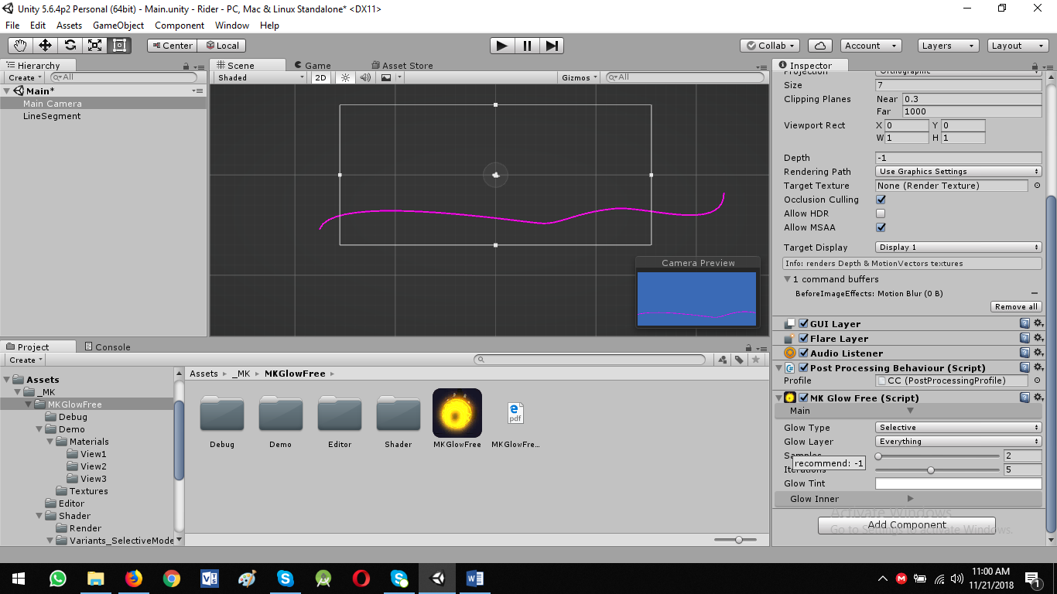

* Now choose what we want to glow
* Glow Type:
  + Selective: Only specific layer to glow
  + Full Screen: Entire screen to glow

We will do work on Selective Glow Type

Go to LineSegment

* Add new layer : Layer -> Default -> drop down menu -> Add layer

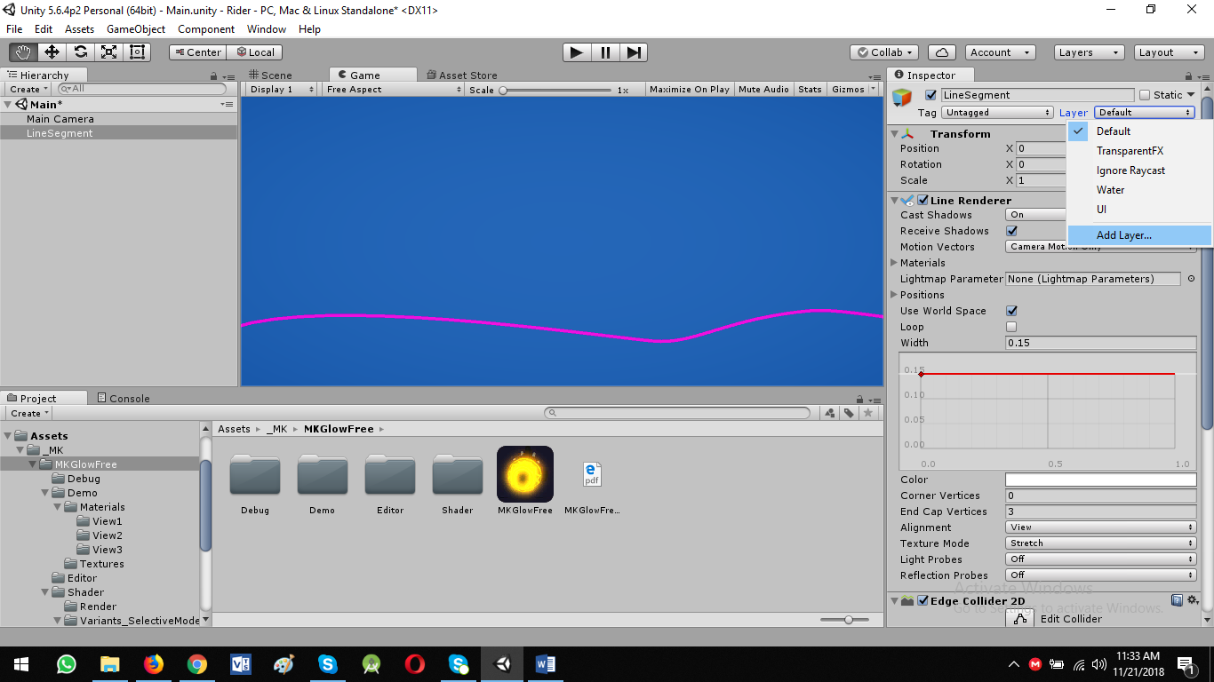

* User Layer 8: Lines
* Add Lines Layer to LineSegment

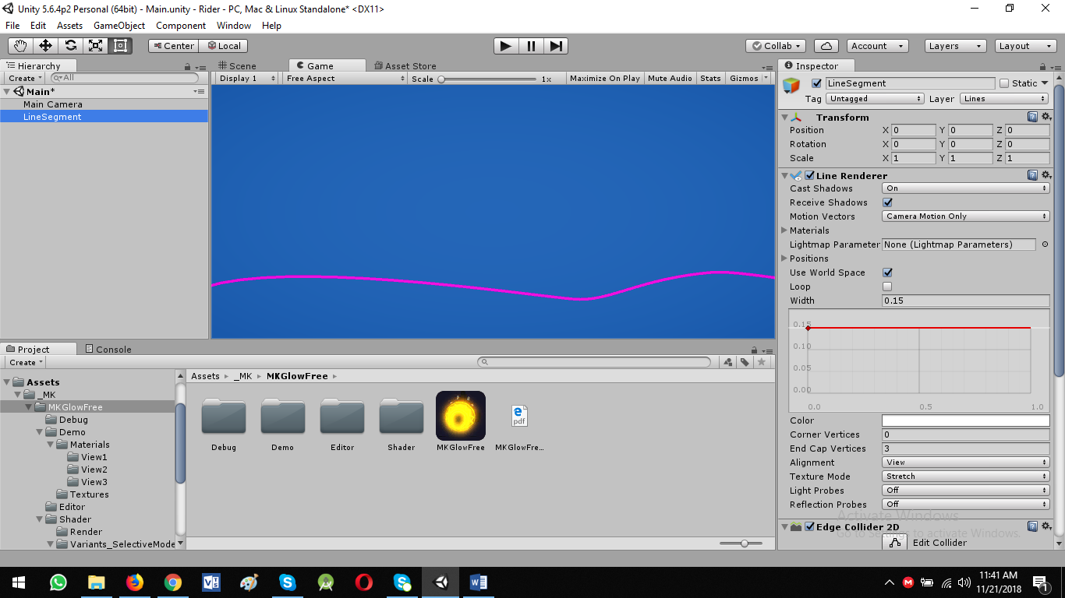

Now go to Main Camera

* MK Glow Free (Script) : Main -> Glow Layer -> Lines

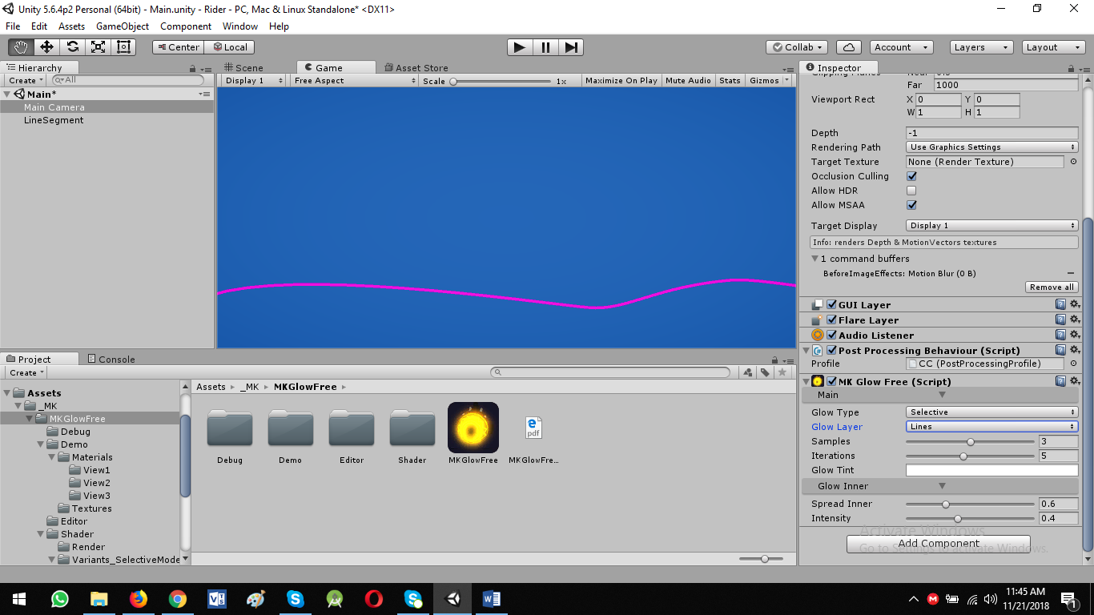

Till our line is not glowing, now we add to add glowing material to line

We have already added material: **LinePurple in assets**

* Select Shader: MK->Glow->Selective->Self-Illumin->Diffuse
* Select Shader: MK->Glow->Selective->Sprites->Diffuse
* Add Glow Texture: Select different colors -> Debugmotion

We want a uniform Glow by using Tint & Color Glow variables

Let’s create a square with white background 16*16 dimension and save with name: square in unity workspace rider->assets folder

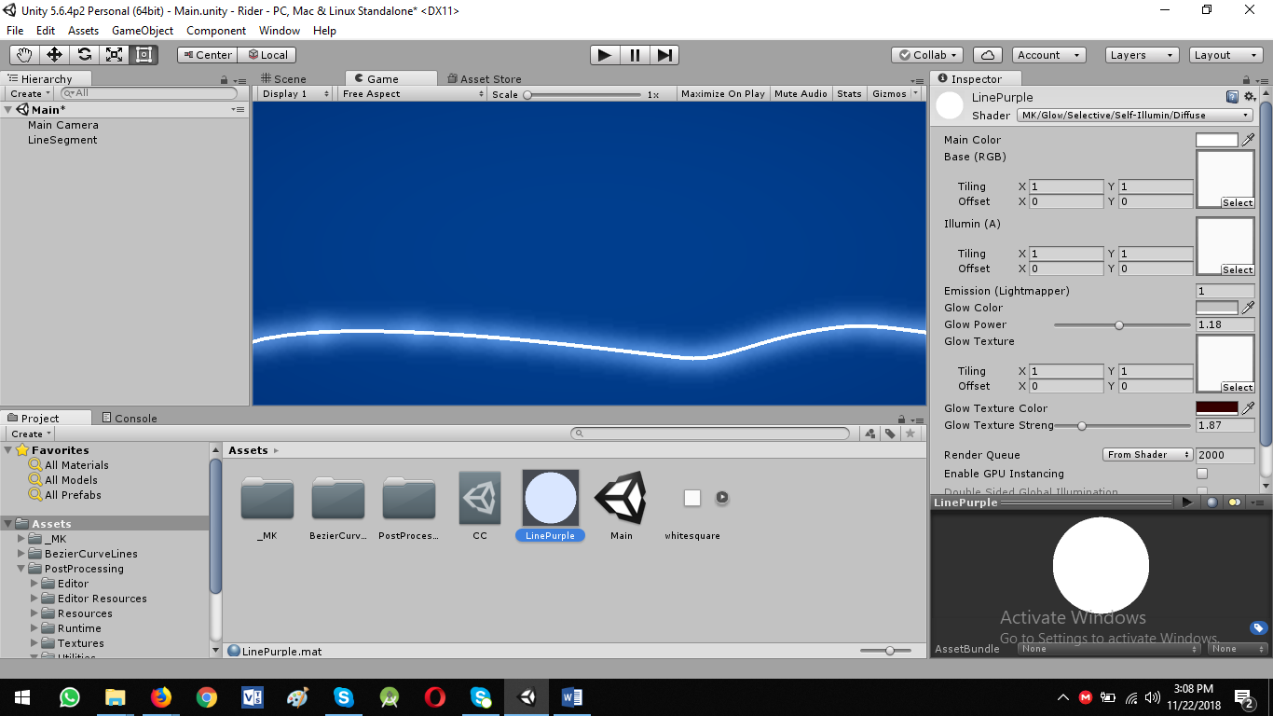

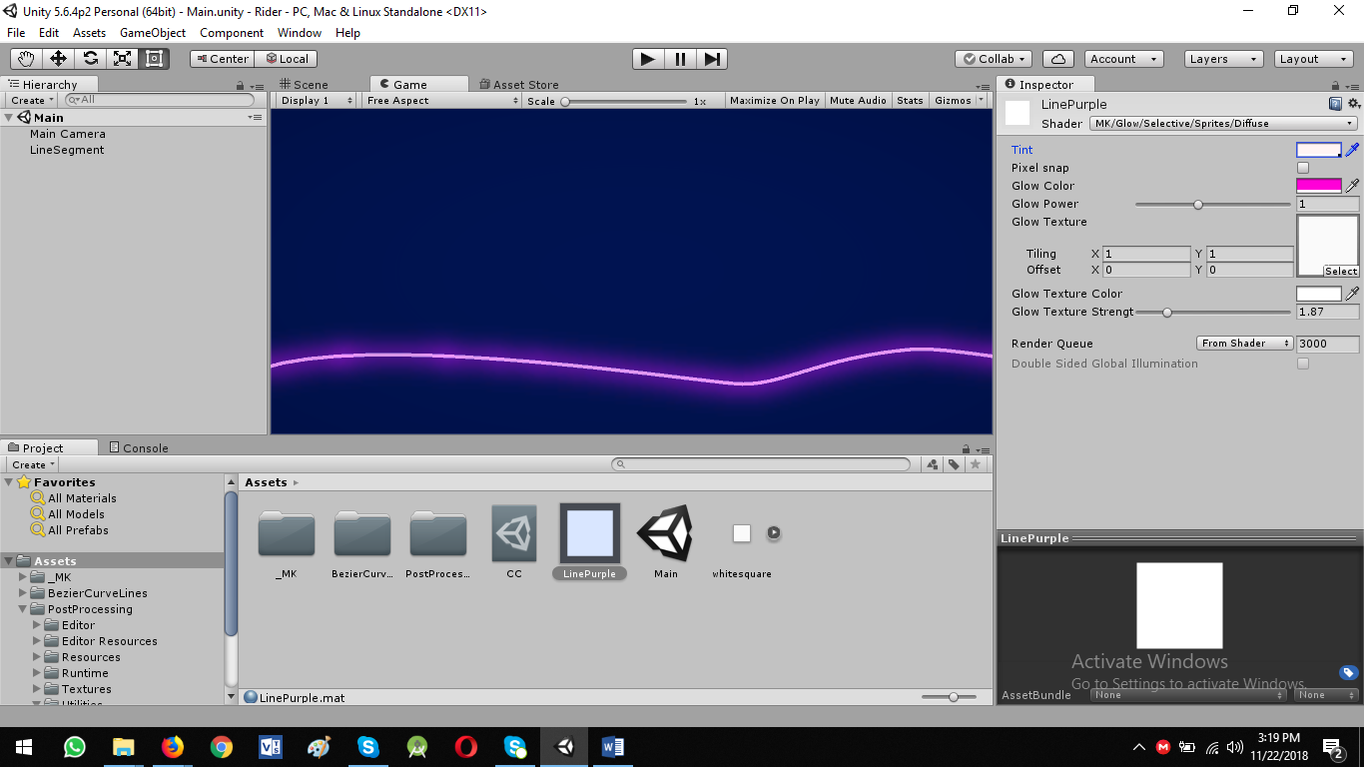

* You can control glow power: Set value: 1
* Tint Color: basically line color
* Glow Color: glowing color of line separate from line color

Go to Main Camera:

Glow Inner Settings:

* Spread Inner: 0.5
* Intensity: 0.4

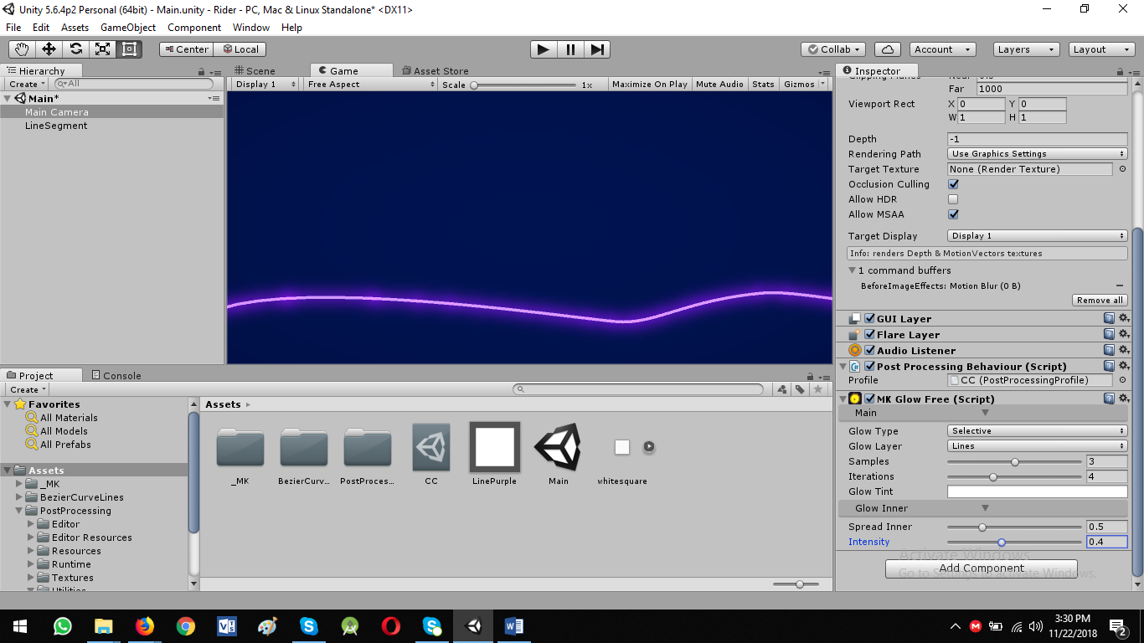

Now just duplicate the LineSegment

* CTRL + C -> CTRL + V
* Go to Bezier Curve Collider: Reset
* Just Uncheck: Use World Space to move the line
* Duplicating you can remove the points from line

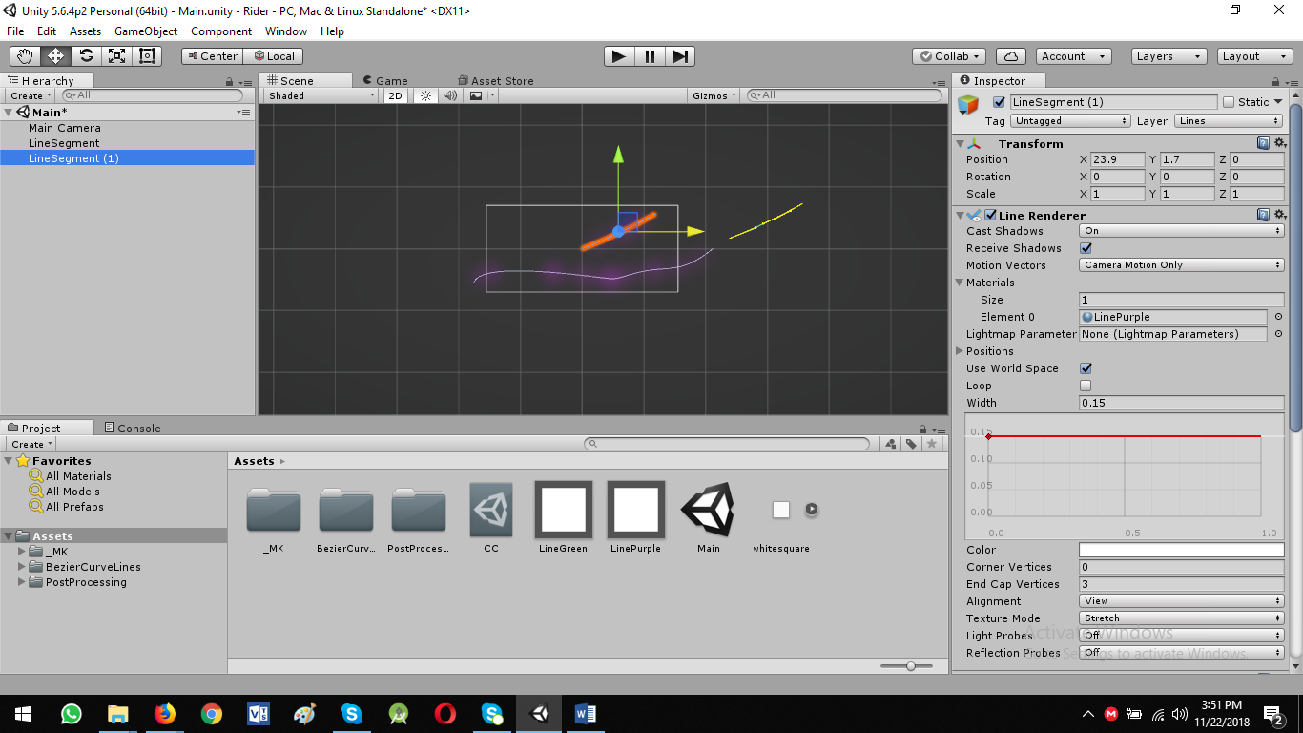

Now duplicate the material: LinePurple: Ctrl + D, rename it to LineGreen to show new duplicated line with green color